Questions

True/False and Explain
Aggregate Supply
- At full employment, there is no unemployment.
- Along the LAS curve, a rise in the price level and all resource prices increase the aggregate quantity of goods and services supplied.
- Along the SAS curve, a rise in the price level in- creases the aggregate quantity of goods and services supplied.
- Both the long-run and short-run aggregate supply curves shift rightward when the quantity of capital increases.
- Any factor that shifts the short-run aggregate sup- ply curve also shifts the long-run aggregate supply curve.
Aggregate Demand
- Aggregate demand equals consumption expendi- ture plus investment plus government purchases plus exports minus imports.
- According to the wealth effect, the lower the quan- tity of real wealth, the larger will be the quantity of real GDP demanded.
- The term “monetary policy” refers to the govern- ment’s spending more money to purchase more goods and services.
Macroeconomic Equilibrium
- Long-run macroeconomic equilibrium occurs when real GDP equals potential GDP.
- In the short run, an increase in expected future profits raises the price level and increases real GDP.
- If the economy is in equilibrium at below full em- ployment, there is a recessionary gap.
- A rise in the money wage rate increases short-run aggregate supply, that is, shifts the short-run aggre- gate supply curve rightward.
- If aggregate demand increases so the economy is producing more output than potential real GDP, then, with the passage of time, the money wage rate will rise in response to the higher price level.
U.S. Economic Growth, Inflation, and Cycles
- If the aggregate demand curve shifts rightward by more than the short-run aggregate supply curve shifts rightward, the price level rises.
- If the aggregate demand curve and the short-run aggregate supply curve both shift rightward at the same time, real GDP increases.
- The main forces generating persistent growth in real GDP are those that cause increases in long-run aggregate supply.
Macroeconomic Schools of Thought
- All macroeconomic schools of thought agree that the economy is self-regulating and would operate at full employment if left alone.

Multiple Choice
Aggregate Supply
- Long-run aggregate supply is the level of real GDP at which
  - aggregate demand always equals short-run aggre- gate supply.
  - full employment occurs.
  - more than full employment occurs.
  - prices are sure to rise
- Along which curve do money wages and the price level change in the same proportion?
  - Both the SAS and the LAS curves.
  - Only the SAS curve.
  - Only the LAS curve.
  - Neither the SAS curve nor the LAS curve.

- Long-run aggregate supply will increase for all the following reasons EXCEPT
  - reduced money wages.
  - increased human capital.
  - introduction of new technology.
  - increased capital.

- A technological improvement shifts
  - both the SAS and LAS curves rightward.
  - both the SAS and LAS curves leftward.
  - the SAS curve rightward, but it leaves the LAS
unchanged.
  - the LAS curve rightward, but it leaves the SAS
curve unchanged.

- An increase in the money wage rate shifts
  - both the SAS and LAS curves rightward.
  - both the SAS and LAS curves leftward.
  - the SAS curve leftward, but leaves the LAS curve unchanged.
Use Table 7.1 for the next four questions.

TABL E 7.1

Multiple Choice Questions 11, 12, 13, 14

  - the LAS curve rightward, but leaves the SAS
curve unchanged.

Price level
Aggregate
demand (billions of
Short-run
aggregate supply (billions
Long-run
aggregate supply (billions of

Aggregate Demand
- The aggregate demand curve (AD) illustrates that, as the price level falls,
  - the quantity of real GDP demanded increases.
  - the quantity of real GDP demanded decreases.
  - the AD curve shifts rightward.
2000 dollars) of 2000 dollars)
2000 dollars)

  - the AD curve shifts leftward.
100 | $800 | $600 | $600
110 | 700 | 700 | 600
120 | 600 | 800 | 600
130 | 500 | 900 | 600

- As the price level rises, the quantity of real wealth
and the aggregate quantity demanded .
  - increases; increases
  - increases; decreases
  - decreases; increases
  - decreases; decreases
- Which of the following is classified as monetary policy?
  - The government changing the amount of its purchases.
  - The government changing its level of taxation.
  - The government changing interest rates.
  - The government financing a change in money wages.

- Which of the following shifts the aggregate demand curve rightward?
  - An increase in expected inflation.
  - An increase in taxes.
  - A fall in the price level.
  - A rise in the price level.

Macroeconomic Equilibrium
- Short-run macroeconomic equilibrium occurs at the level of GDP where the
  - economy is at full employment.
  - AD curve intersects the SAS curve.
  - SAS curve intersects the LAS curve.
  - AD curve intersects the LAS curve.
- In the short-run macroeconomic equilibrium, the
price level is and the level of real GDP is billion.
a. 100; $600
b. 110; $700
c. 120; $600
d. 130; $600

- In the short run, the economy is in
  - a full-employment equilibrium and resource prices will not change.
  - an above full-employment equilibrium and re- source prices will rise.
  - an above full-employment equilibrium and re- source prices will fall.
  - a below full-employment equilibrium and re- source prices will fall.

- In the short-run equilibrium, there is
  - an inflationary gap of $100 billion.
  - an inflationary gap of $50 billion.
  - a recessionary gap of $50 billion.
  - a recessionary gap of $100 billion.
- Assuming no changes in aggregate demand or long- run aggregate supply, in the long-run macroeco- nomic equilibrium, the price level is and the level of real GDP is billion.
a. 100; $600
b. 110; $700
c. 120; $600
d. 130; $600

- If real GDP is greater than potential real GDP, then the economy is
  - not in macroeconomic equilibrium.
  - in a full-employment equilibrium.
  - in an above full-employment equilibrium.
  - in a below full-employment equilibrium.
- A below full-employment equilibrium can be the result of the
  - AD curve shifting rightward.
  - SAS curve shifting rightward.
  - LAS curve shifting leftward.
  - AD curve shifting leftward.

Use Figure 7.4 for the next four questions.
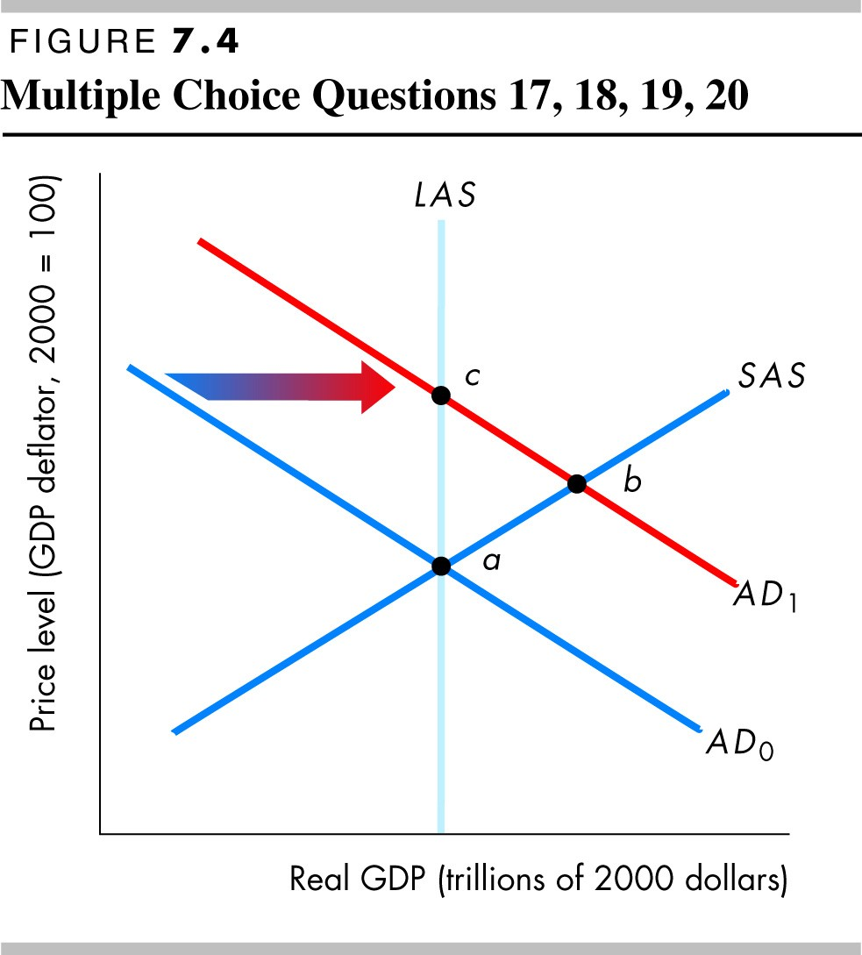

- Which of the following factors might have shifted the aggregate demand curve rightward?
  - Reduced taxes
  - Less investment
  - A decrease in government purchases
  - Higher money wages

- After the aggregate demand curve has shifted per-
manently to AD1, the new short-run macroeco- nomic equilibrium is at point
  - point a.
  - point b.
  - point c.
  - No point identified with a letter in the figure.
- When the economy in Figure 7.4 is moving to its long-run equilibrium, which curve shifts?
  - The LAS curve shifts rightward.
  - The LAS curve shifts leftward.
  - The SAS curve shifts rightward.
  - The SAS curve shifts leftward.

- After the aggregate demand curve has shifted per-
manently to AD1, the new long-run macroeconomic equilibrium will be at
  - point a.
  - point b.
  - point c.
  - No point identified with a letter in the figure.

U.S. Economic Growth, Inflation, and Cycles
- The fact that the short-run aggregate supply and aggregate demand curves do not shift at a fixed, steady pace explains
  - persistent inflation.
  - business cycles.
  - trend growth in real GDP.
  - large government budget deficits.

- Persistent inflation is caused by
  - persistent rightward shifts in the AD curve.
  - persistent rightward shifts in the SAS curve.
  - the tendency for long-run aggregate supply to increase faster than aggregate demand.
  - persistent leftward shifts in the SAS and AD
curves.

Macroeconomic Schools of Thought
- Which school of thought says that expectations are the most important influence on aggregate demand?
  - Keynesian school
  - classical school
  - monetarist school
  - Both Keynesian and monetarist schools
- Which school of thought believes the economy is self-regulating?
  - Keynesian school
  - classical school
  - monetarist school
  - Both classical and monetarist schools

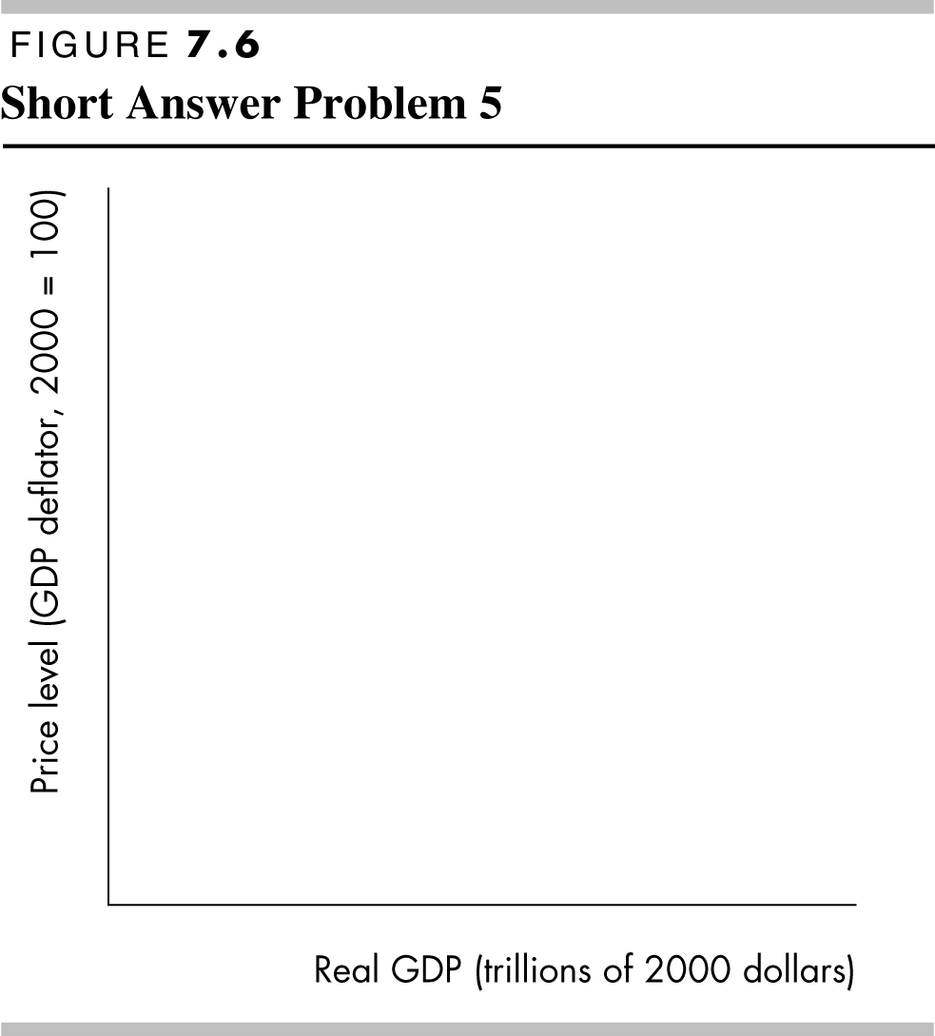
Short Answer Problems
- Why is the LAS curve vertical?
- Why does the SAS curve have a positive slope?
- The international substitution effect implies that an increase in the price level will lead to a decrease in the aggregate quantity of goods and services de- manded. Explain why.

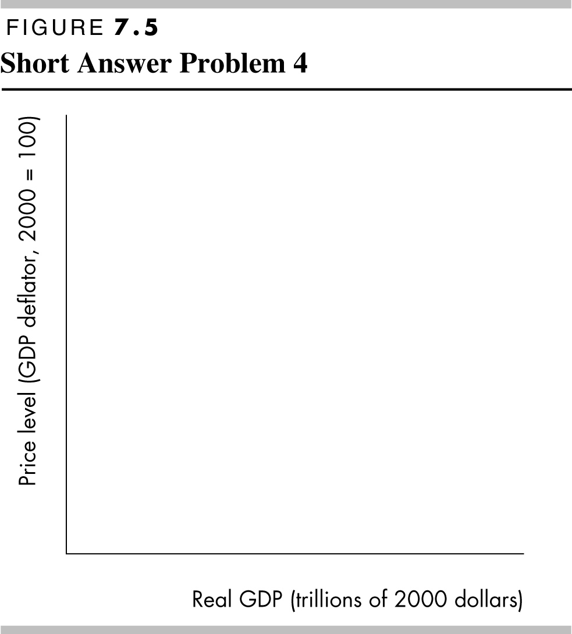
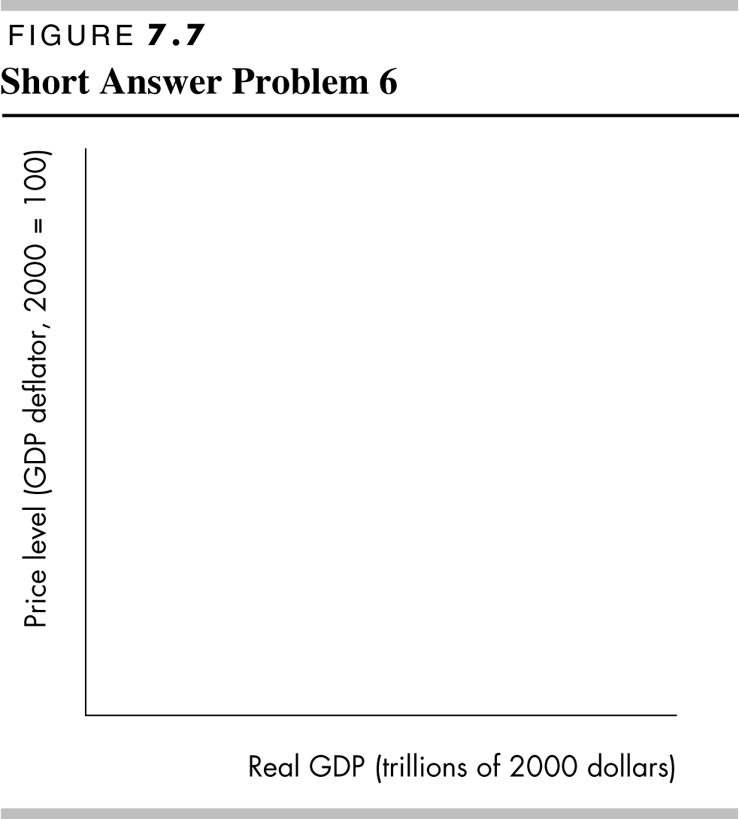
- In Figure 7.5 illustrate an economy in long-run equilibrium, producing at the full-employment level of production. Indicate the equilibrium price level and level of real GDP. Also indicate the po- tential level of real GDP.
- In Figure 7.6 illustrate an economy in short-run equilibrium producing at a below full-employment level of production. Indicate the equilibrium price level and level of real GDP and show the amount of the recessionary gap.
- In Figure 7.7 illustrate an economy in short-run equilibrium producing at an above full-employ- ment level of production. Indicate the equilibrium price level and level of real GDP and show the amount of the inflationary gap.

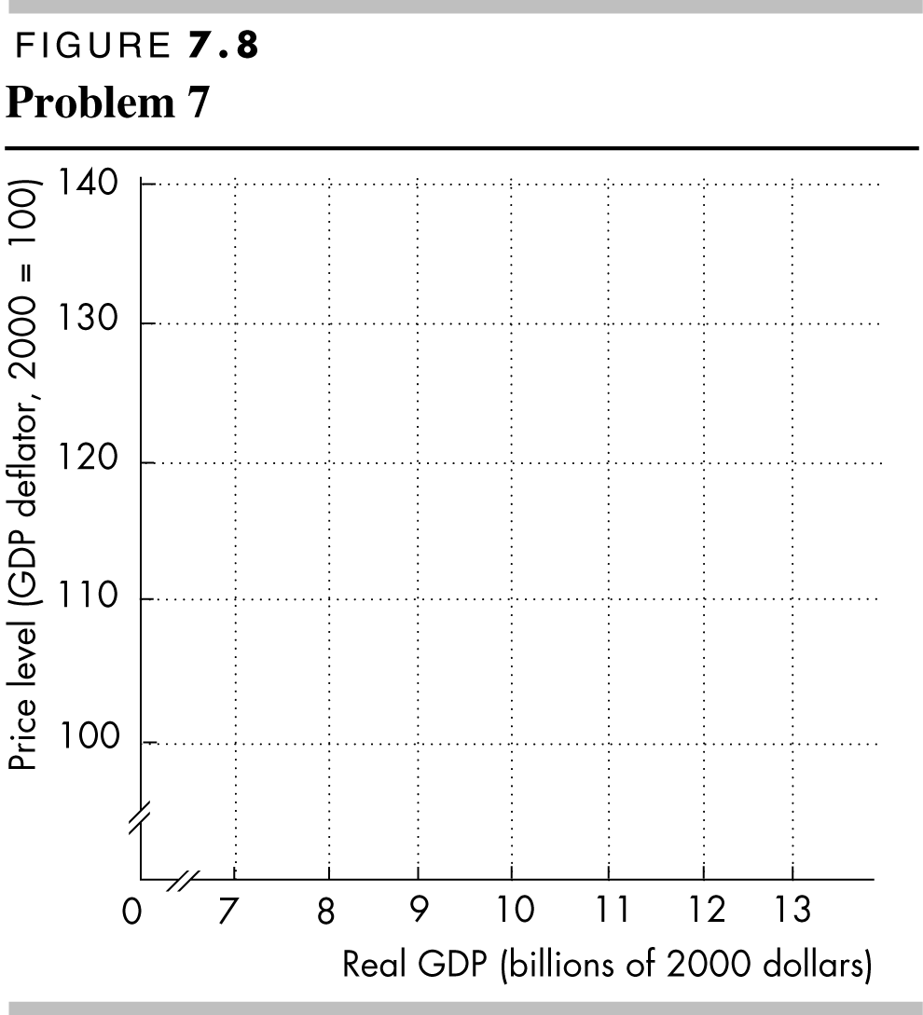

TABL E 7.2

Short Answer Problem 7

an above full-employment, a full-employment, or a below full-employment equilibrium. If ei- ther an inflationary or recessionary gap exists, calculate what it equals.
d. As time passes, what happens to move the econ- omy back to its long-run equilibrium? Illustrate this process in Figure 7.8 by drawing any other curves you need. Label the long-run equilib- rium point c. What is the equilibrium level of GDP and price level in the long run?
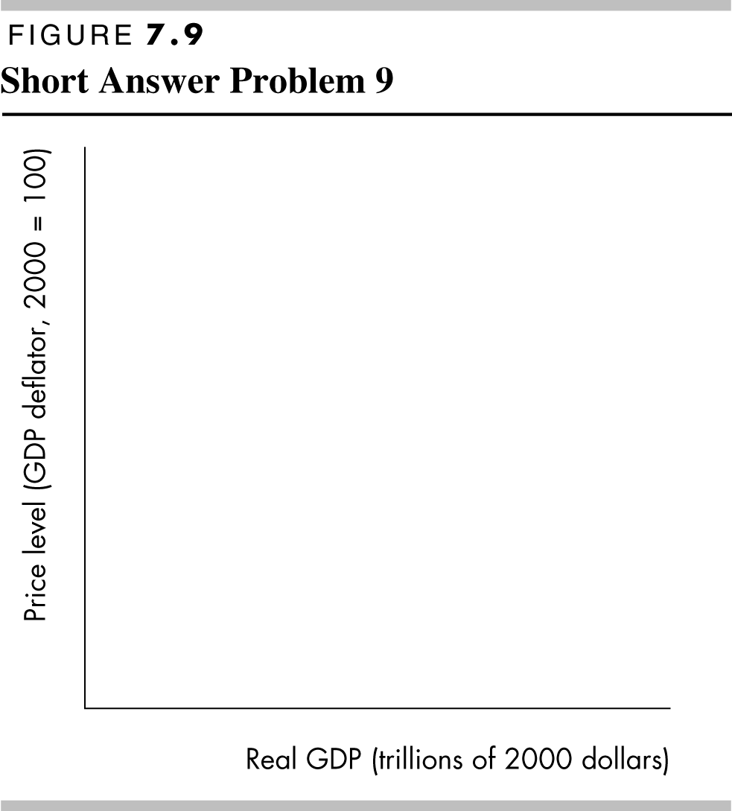
8. Suppose that the AD curve shifts rightward. In the long run, how does this shift affect the SAS curve? Why does the SAS change only in the long run?

Aggregate
Short-run
Long-run

demand
aggregate supply aggregate supply

Price level
(billions of 2000 dollars)
(billions of 2000 dollars)
(billions of 2000 dollars)

100 | $11 | $9 | $10
110 | 10 | 10 | 10
120 | 9 | 11 | 10
130 | 8 | 12 | 10
140 | 7 | 13 | 10

- Table 7.2 shows the initial aggregate demand, short-run, and long-run aggregate supply schedules for the nation of Macro.
  - Draw the AD, SAS, and LAS curves for Macro in Figure 7.8. Label the equilibrium point a. What is the equilibrium level of real GDP and price level?
  - Suppose that government purchases increase so that aggregate demand increases by $2 billion at every price level. In Figure 7.8 draw the new aggregate demand curve. Label the new short run equilibrium point b. What is the equilib- rium level of real GDP and price level in the short run?
  - Why is point b not a long-run equilibrium? In your answer, mention the level of potential real GDP, and describe whether point b represents

- Suppose that new, productivity enhancing tech- nologies are discovered. In Figure 7.9 show how these technological advances affect the equilibrium level of real GDP and the price level.
- Why are increases in the quantity of money the factor that created the persistent inflation that the United States has experienced for the last several decades?
- Keynesian economists generally believe that gov- ernment fiscal and monetary policy is desirable. Classical economists generally disagree. What ac- counts for this difference in views?

  - You’re the Teacher
- “I’ve really tried, but I just don’t see why a change in the price level doesn’t shift the short-run aggregate supply curve. After all, it seems like when the price level falls, firms should decrease the amount they produce and that this should shift the SAS curve. Plus, I’m a little shaky on how to use the AS/AD model. I sure hope the AS/AD model isn’t too important so that I don’t get hurt badly by not knowing this.” In truth, your friend may be mor- tally wounded by not understanding the difference between a shift of a curve and a movement along a curve. Use an example in which the AD curve shifts leftward to help explain to your friend how to use the AS/AD model for the short run and also why a drop in the price level does not shift the SAS curve.
- After you have helped overcome the previous problems, your friend offers an observation: “I think I’m catching on to this stuff now. And the diagram you just drew was really helpful. But, is that dia- gram the end of the story? Or does something else happen as more time passes?” Basically, your friend is asking you to complete the explanation you started by showing what happens in the long run. Doing so would help reinforce your friend’s grasp of the AS/AD model. So, using another diagram, show what happens in the long run after an initial decrease in aggregate demand has occurred.

